Hydraulic Performance Curves 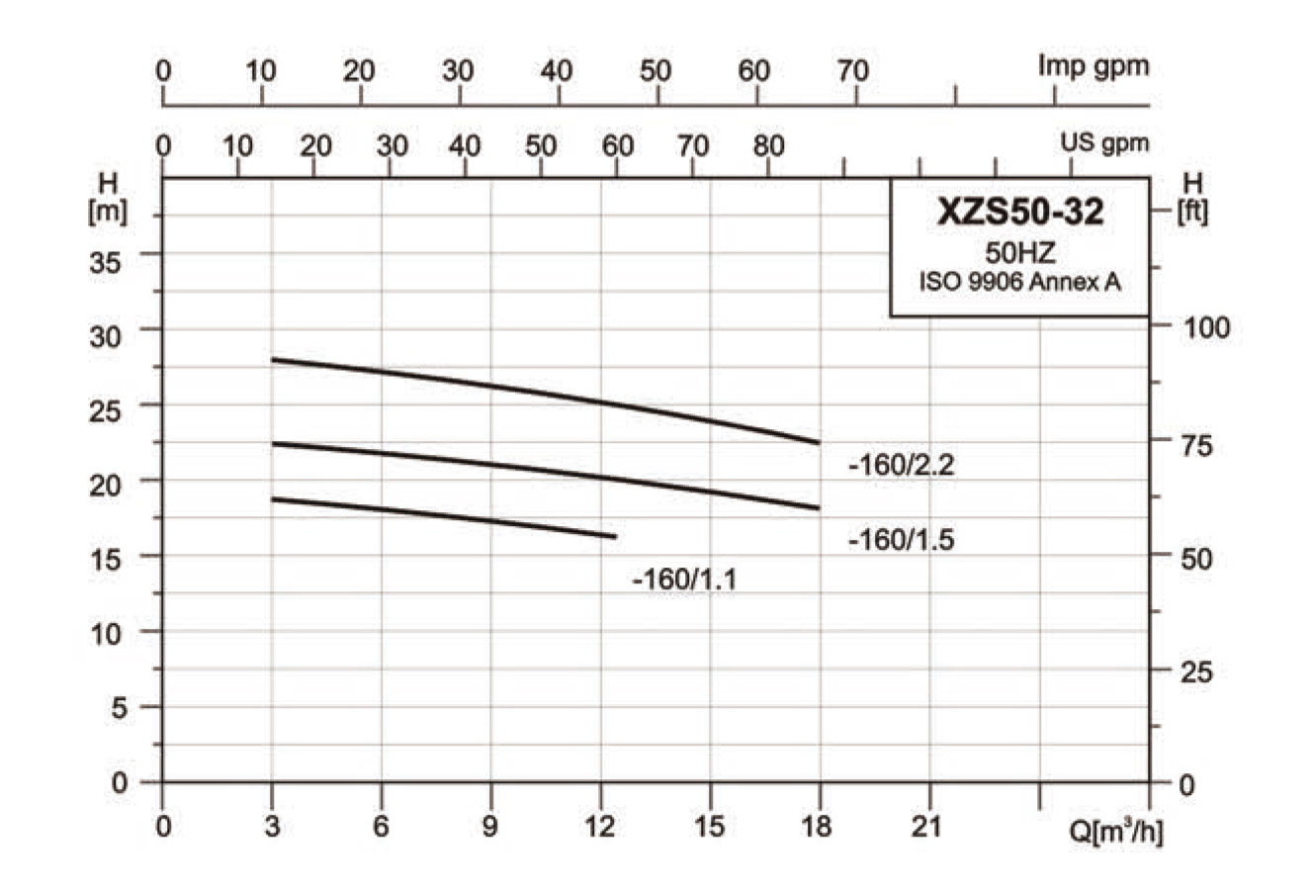
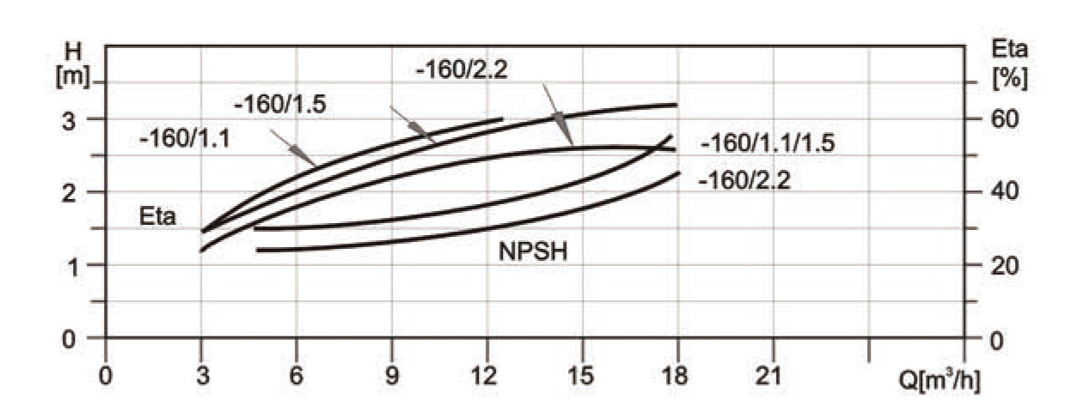
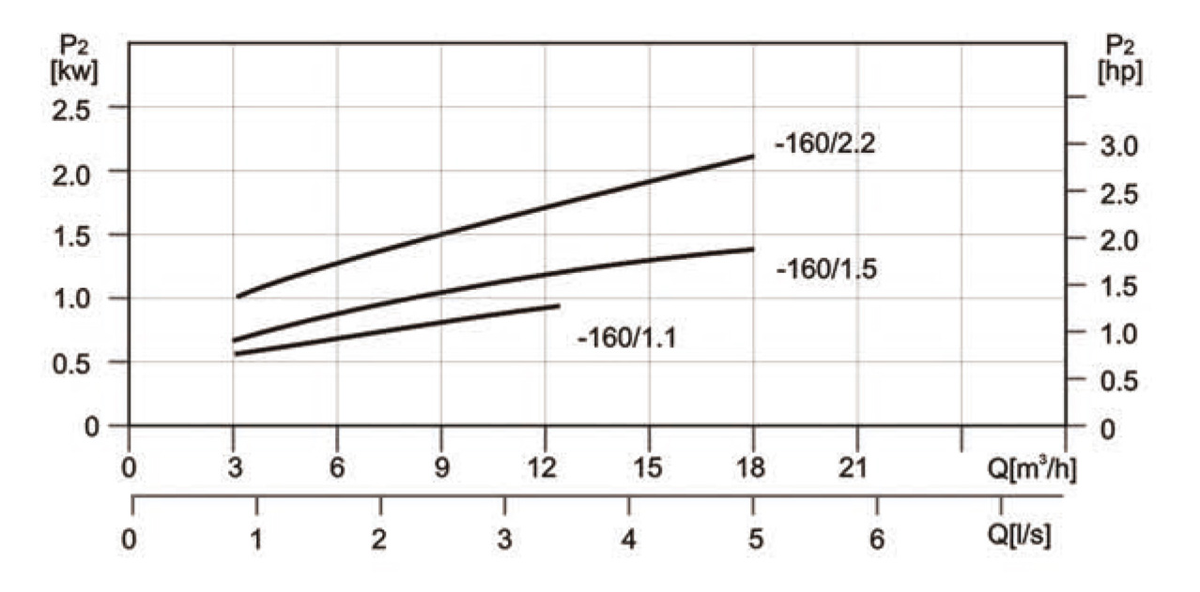
Hydraulic Performance Data
MODEL | POWER | Q | 3 | 6.3 | 9 | 12.5 | 15 | 18
MODEL | (kW) | (m³/h)
XZS50-32-160/1.1 | 1.1 | H(m) | 18.7 | 18 | 17.2 | 16.4
XZS50-32-160/1.5 | 1.5 | H(m) | 22.5 | 22 | 21 | 20 | 19 | 18
XZS50-32-160/2.2 | 2.2 | H(m) | 28 | 27 | 26.3 | 25 | 24 | 22.5

Hydraulic Performance Curves
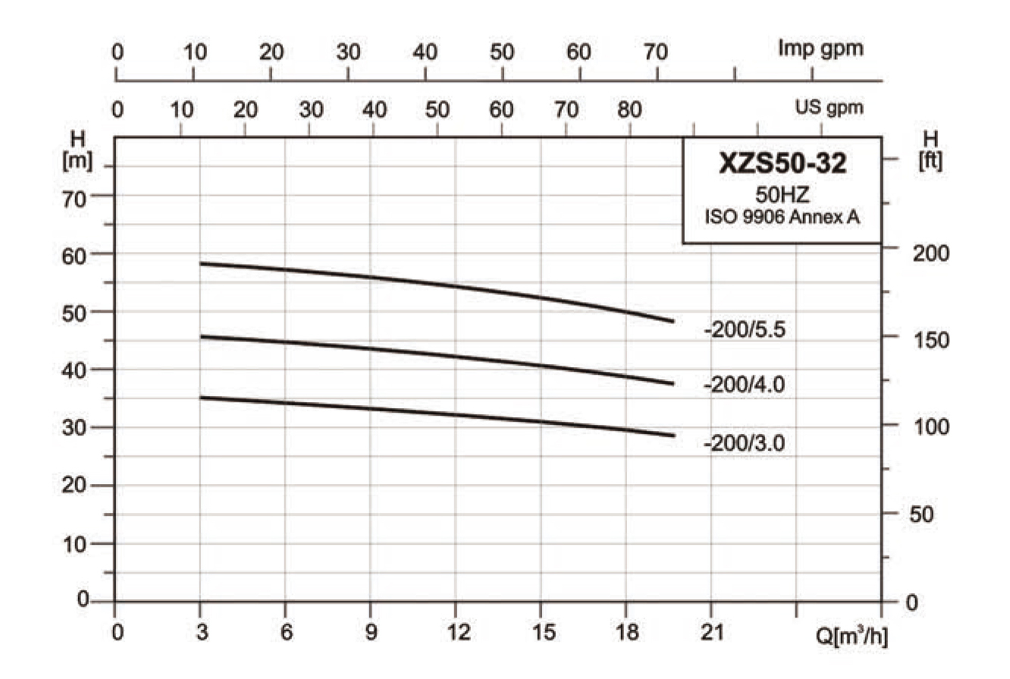
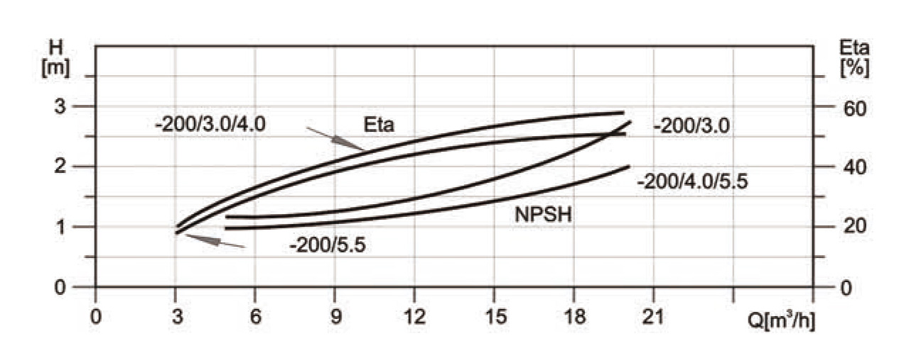
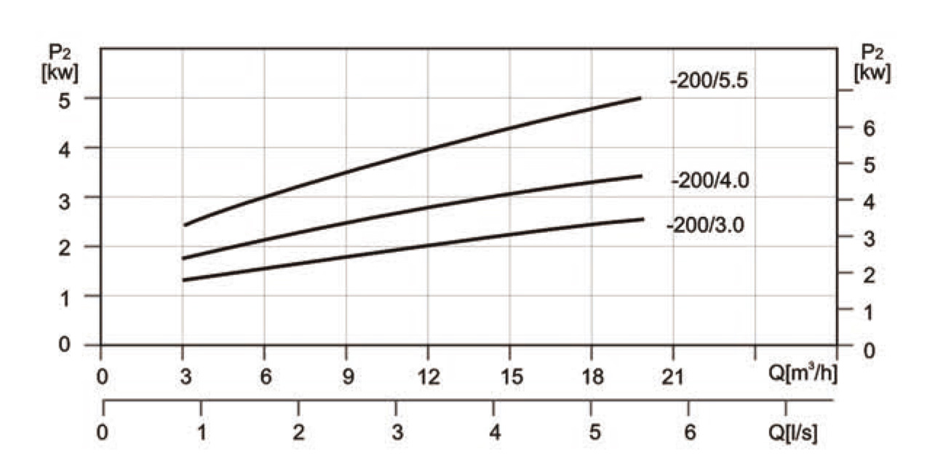
Hydraulic Performance Data
MODEL | POWER | Q | 3 | 6.3 | 9 | 12.5 | 15 | 18 | 20
MODEL | (kW) | (m³/h)
XZS50-32-200/3.0 | 3.0 | H(m) | 34.9 | 34.1 | 33.3 | 32 | 31 | 29.8 | 28.9
XZS50-32-200/4.0 | 4.0 | H(m) | 45.7 | 44.8 | 43.7 | 42 | 40.7 | 39 | 37.7
XZS50-32-200/5.5 | 5.5 | H(m) | 58.5 | 57.2 | 56 | 54 | 52.5 | 50 | 48.5

Hydraulic Performance Curves
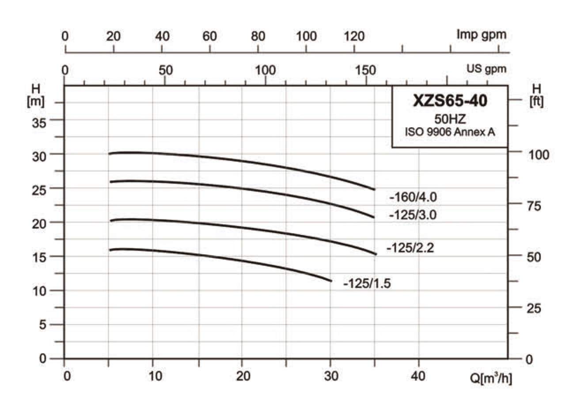
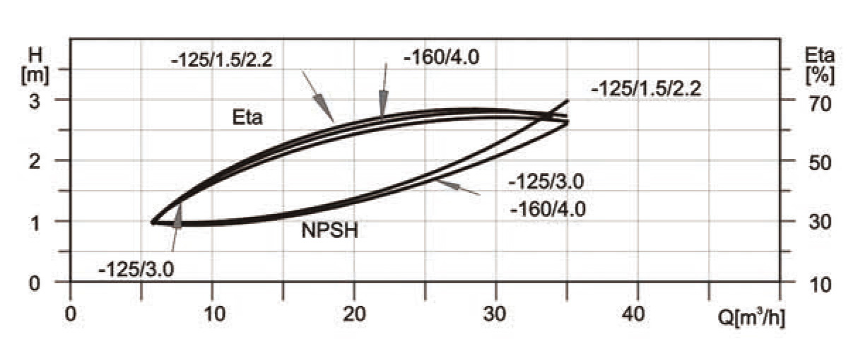
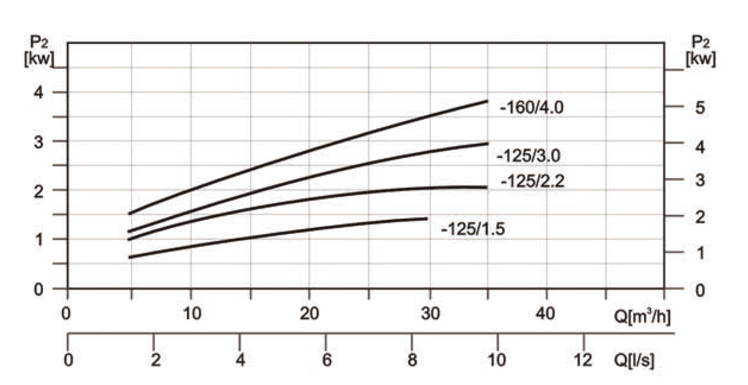
Hydraulic Performance Data
MODEL | POWER | Q | 5 | 10 | 15 | 20 | 25 | 30 | 35
MODEL | (kW) | (m³/h)
XZS65-40-125/1.5 | 1.5 | H(m) | 15.5 | 15.4 | 15 | 14.4 | 13 | 11.3
XZS65-40-125/2.2 | 2.2 | H(m) | 20 | 19.7 | 19.5 | 19 | 18 | 16.7 | 15.2
XZS65-40-125/3.0 | 3.0 | H(m) | 25.7 | 25.3 | 25.1 | 24.8 | 24 | 22.3 | 20.3
XZS65-40-160/4.0 | 4.0 | H(m) | 30 | 29.7 | 29.3 | 28.9 | 28 | 26.5 | 24.5

Hydraulic Performance Curves
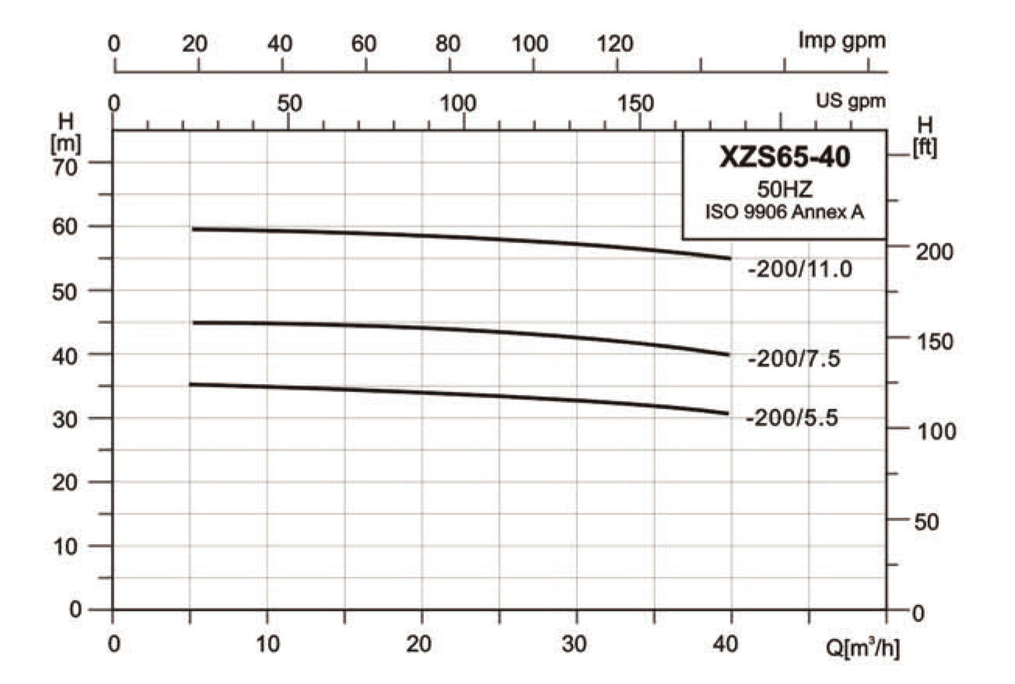
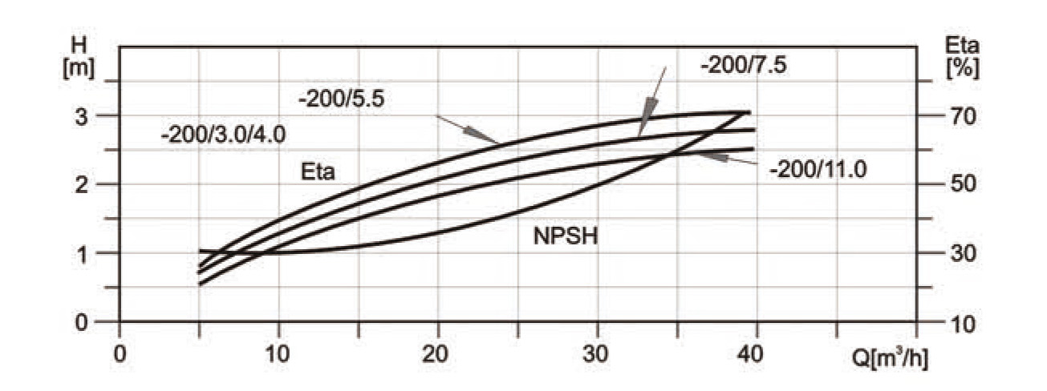
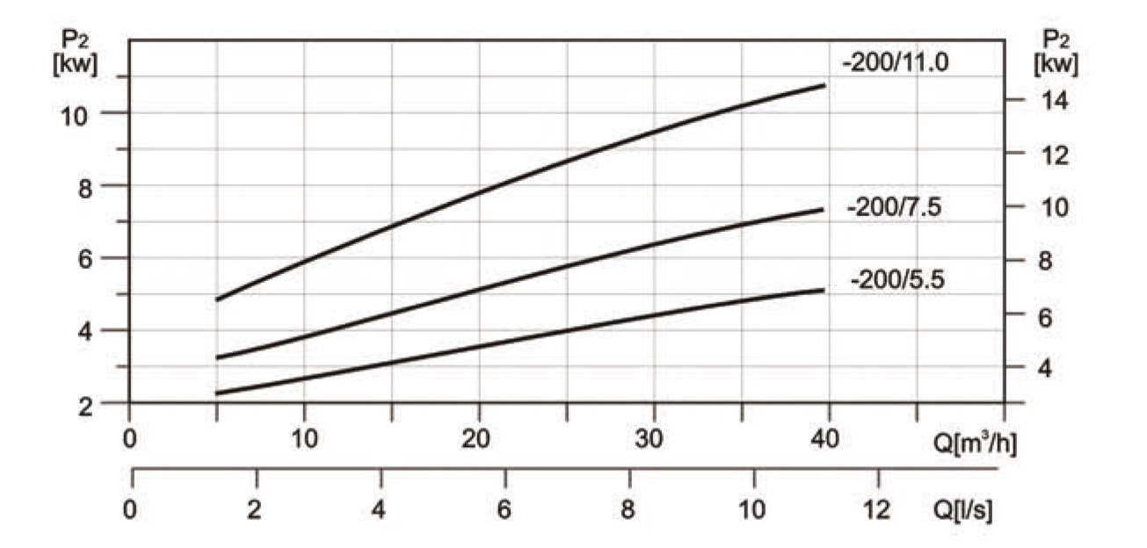
Hydraulic Performance Data
MODEL | POWER | Q | 5 | 10 | 15 | 20 | 25 | 30 | 35 | 40
MODEL | (kW) | (m³/h)
XZS65-40-200/5.5 | 5.5 | H(m) | 37.4 | 37.2 | 36.7 | 36.4 | 36 | 35.5 | 34.6 | 33.3
XZS65-40-200/7.5 | 7.5 | H(m) | 48 | 47.5 | 47 | 46.6 | 46 | 45.2 | 44.5 | 43.3
XZS65-40-200/11.0 | 11 | H(m) | 64 | 63.5 | 63 | 62.5 | 62 | 61.5 | 60.5 | 59

Hydraulic Performance Curves
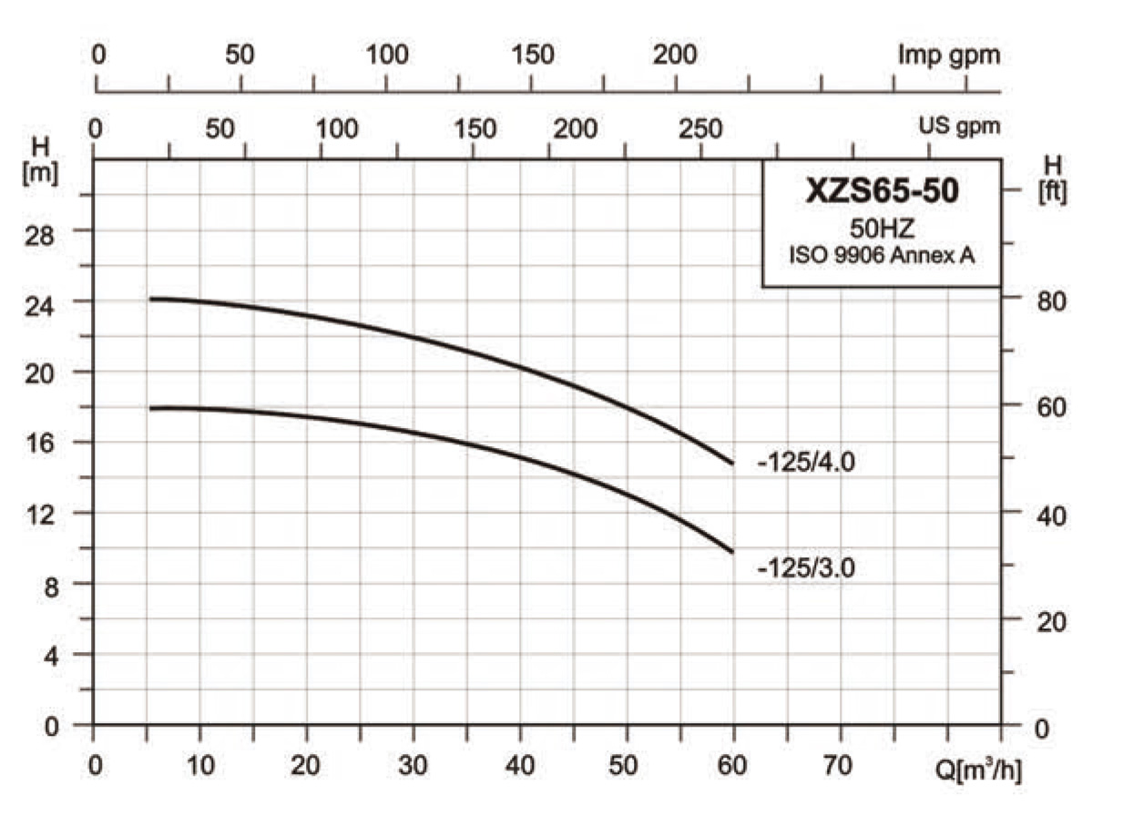
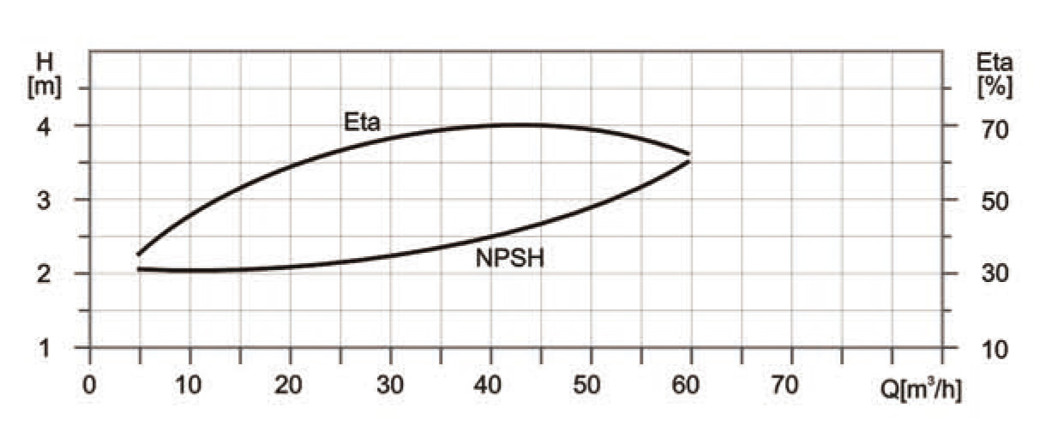
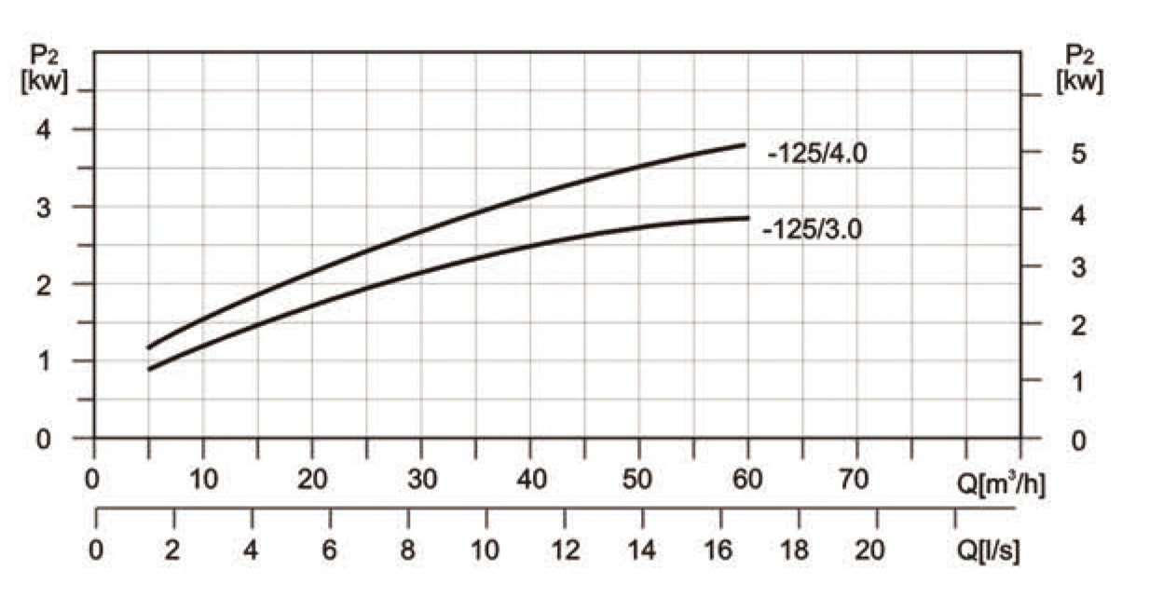
Hydraulic Performance Data
MODEL | POWER | Q | 5 | 10 | 20 | 30 | 40 | 50 | 60
MODEL | (kW) | (m³/h)
XZS65-50-125/3.0 | 3 | H(m) | 18 | 17.8 | 17.2 | 16.4 | 15.1 | 13 | 10
XZS65-50-125/4.0 | 4 | H(m) | 24.2 | 24.2 | 23.6 | 23.6 | 20.7 | 18 | 14.8

Hydraulic Performance Curves
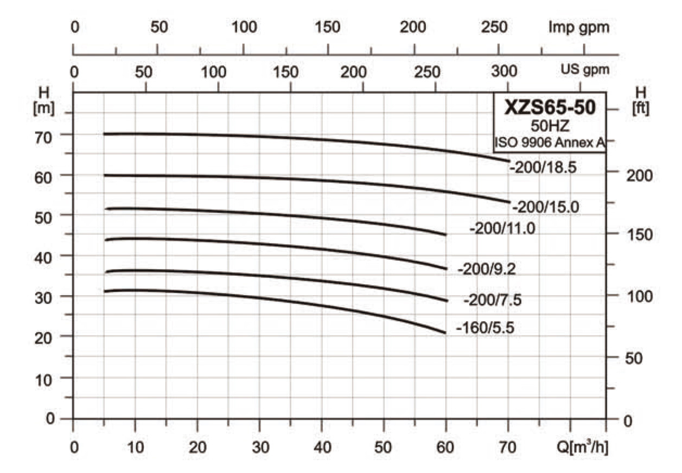
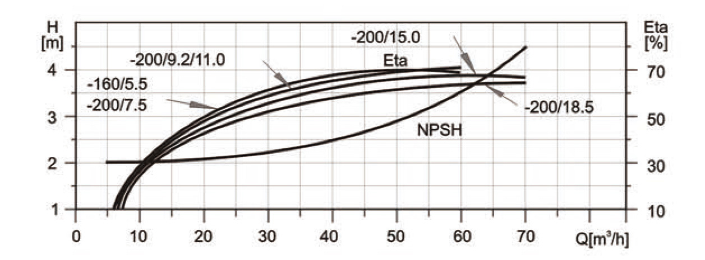
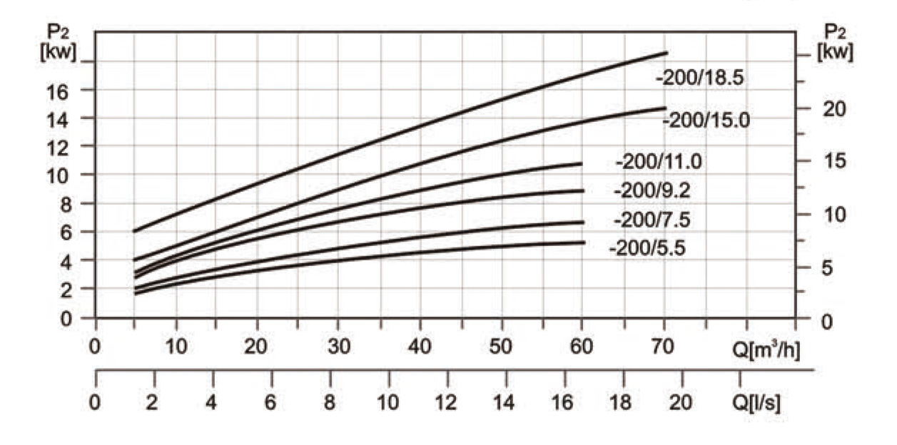
Hydraulic Performance Data
MODEL | POWER | Q | 5 | 10 | 20 | 30 | 40 | 50 | 60 | 70
MODEL | (kW) | (m³/h)
XZS65-50-160/5.5 | 5.5 | H(m) | 31.6 | 31.5 | 31 | 30 | 28 | 25 | 21.5
XZS65-5-200/7.5 | 7.5 | H(m) | 36.9 | 36.6 | 36.4 | 35.6 | 34.1 | 32 | 29.6
XZS65-50-200/9.2 | 9.2 | H(m) | 43.5 | 43.5 | 43.5 | 43 | 42 | 40 | 37.5
XZS65-50-200/11.0 | 11 | H(m) | 51.5 | 51.5 | 51 | 50 | 49.3 | 48 | 45.6
XZS65-50-200/15.0 | 15 | H(m) | 59.7 | 59.7 | 59.6 | 59.5 | 59 | 58 | 56.2 | 53
XZS65-50-200/18.5 | 18.5 | H(m) | 70.2 | 70.2 | 70.1 | 70 | 69.1 | 68 | 66.4 | 64

Installation Sketch
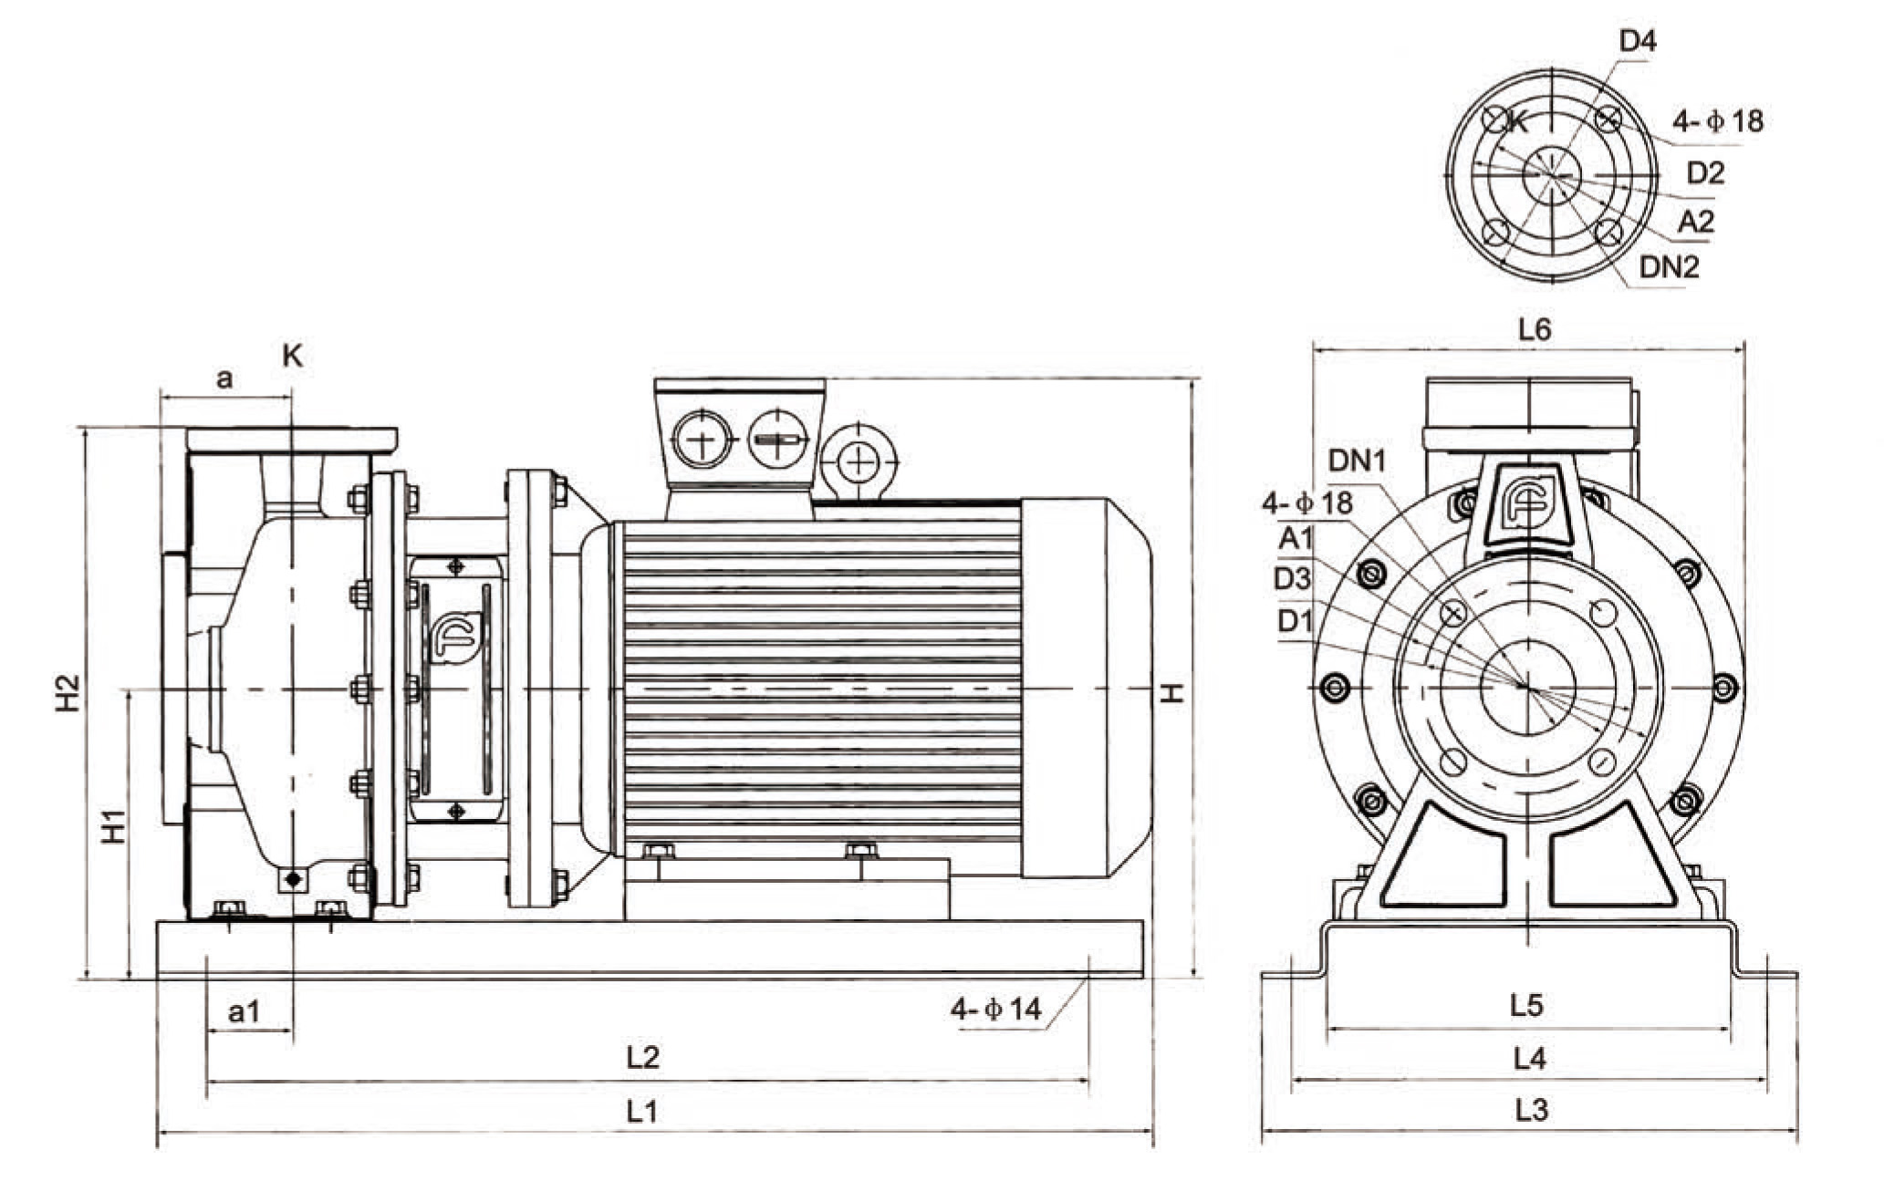
Installation Dimensions
Model | Size (mm) |  |  |  |  |  |  |  |  |  |  |  |  |  |  |  |  |  |  | Weight
Model | DN1 | DN2 | A1 | A2 | D1 | D2 | D3 | D4 | a | a1 | H | H1 | H2 | L1 | L2 | L3 | L4 | L5 | L6 | (kg)
XZS50-32-160/1.1 | 50 | 32 | 98 | 75 | 125 | 100 | 160 | 139 | 80 | 32 | 290 | 152 | 290 | 470 | 370 | 280 | 240 | 192 | 210 | 31
XZS50-32-160/1.5 | 50 | 32 | 98 | 75 | 125 | 100 | 160 | 139 | 80 | 46 | 307 | 152 | 296 | 500 | 430 | 280 | 240 | 192 | 210 | 37
XZS50-32-160/2.2 | 50 | 32 | 98 | 75 | 125 | 100 | 160 | 139 | 80 | 46 | 307 | 152 | 296 | 500 | 430 | 280 | 240 | 192 | 210 | 39
XZS50-32-200/3.0 | 50 | 32 | 98 | 75 | 125 | 100 | 160 | 139 | 84 | 42 | 370 | 200 | 386 | 550 | 460 | 330 | 290 | 242 | 300 | 53
XZS50-32-200/4.0 | 50 | 32 | 98 | 75 | 125 | 100 | 160 | 139 | 84 | 47 | 393 | 200 | 286 | 560 | 480 | 330 | 290 | 242 | 300 | 58
XZS50-32-200/5.5 | 50 | 32 | 98 | 75 | 125 | 100 | 160 | 139 | 84 | 50 | 413 | 200 | 386 | 660 | 580 | 370 | 330 | 280 | 300 | 77
XZS65-40-125/1.5 | 65 | 40 | 118 | 84 | 145 | 110 | 185 | 145 | 80 | 45 | 307 | 152 | 294 | 502 | 430 | 280 | 240 | 192 | 210 | 33
XZS65-40-125/2.0 | 65 | 40 | 118 | 84 | 145 | 110 | 185 | 145 | 80 | 45 | 307 | 152 | 294 | 502 | 430 | 280 | 240 | 192 | 210 | 35
XZS65-40-125/3.0 | 65 | 40 | 118 | 84 | 145 | 110 | 185 | 145 | 80 | 45 | 322 | 152 | 294 | 532 | 460 | 300 | 260 | 212 | 250 | 47
XZS65-40-160/4.0 | 65 | 40 | 118 | 84 | 145 | 110 | 185 | 145 | 80 | 45 | 345 | 152 | 294 | 557 | 480 | 330 | 290 | 242 | 250 | 52
XZS65-40-200/5.5 | 65 | 40 | 118 | 84 | 145 | 110 | 185 | 145 | 100 | 50 | 413 | 200 | 380 | 680 | 580 | 370 | 330 | 280 | 300 | 78
XZS65-40-200/7.5 | 65 | 40 | 118 | 84 | 145 | 110 | 185 | 145 | 100 | 50 | 413 | 200 | 380 | 680 | 580 | 370 | 330 | 280 | 300 | 82
XZS65-40-200/11.0 | 65 | 40 | 118 | 84 | 145 | 110 | 185 | 145 | 100 | 50 | 456 | 200 | 380 | 790 | 690 | 420 | 380 | 330 | 350 | 161
XZS65-50-125/3.0 | 65 | 50 | 118 | 98 | 145 | 125 | 185 | 160 | 86 | 45 | 342 | 172 | 338 | 548 | 468 | 330 | 290 | 242 | 250 | 49
XZS65-50-125/4.0 | 65 | 50 | 118 | 98 | 145 | 125 | 185 | 160 | 86 | 45 | 365 | 172 | 338 | 570 | 490 | 330 | 290 | 242 | 250 | 54
XZS65-50-160/5.5 | 65 | 50 | 118 | 98 | 145 | 125 | 185 | 160 | 100 | 50 | 413 | 200 | 380 | 680 | 580 | 370 | 330 | 280 | 300 | 78
XZS65-50-200/7.5 | 65 | 50 | 118 | 98 | 145 | 125 | 185 | 160 | 100 | 50 | 413 | 200 | 380 | 680 | 580 | 370 | 330 | 280 | 300 | 82
XZS65-50-200/9.2 | 65 | 50 | 118 | 98 | 145 | 125 | 185 | 160 | 100 | 50 | 413 | 200 | 380 | 680 | 580 | 370 | 330 | 280 | 300 | 85
XZS65-50-200/11.0 | 65 | 50 | 118 | 98 | 145 | 125 | 185 | 160 | 100 | 50 | 456 | 200 | 380 | 790 | 690 | 420 | 380 | 330 | 350 | 161
XZS65-50-200/15.0 | 65 | 50 | 118 | 98 | 145 | 125 | 185 | 160 | 100 | 50 | 456 | 200 | 380 | 790 | 690 | 420 | 380 | 330 | 350 | 171
XZS65-50-200/18.5 | 65 | 50 | 118 | 98 | 145 | 125 | 185 | 160 | 100 | 50 | 456 | 200 | 380 | 830 | 730 | 420 | 380 | 330 | 350 | 188

